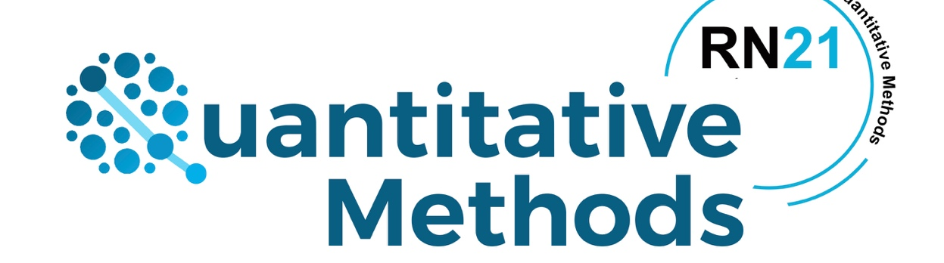
European Sociological Association - Midterm Conference of RN 21- Quantitative Methods 5th – 7th of October 2022, Salamanca, Spain.

Use this document as a template, substituting the texts. Maximum 350 words. Summit this document as a .word file via email to rn21@usal.es

TITLE
Surname1, FirstName1ª, Surname2, FirstName2 ^{b}, ....
ª Affiliation author1, address1, email: e-mail@autor1.es;
^{b} Affiliation author2, address2, email: e-mail@autor2.es; ...

Keywords: up to 5 comma separated keywords.

ABSTRACT

All abstracts should be written in Times New Roman 11, with justified alignment. The top and bottom margins should be 2.5 mm and the left and right margins should be 3 mm.

